**Problem Set 2**

***Due Date:-***Sept 23 at 11:59pm

**Instructions:-**

a. For Problems that require explanations, create space below the question and write your answers.

b. For drawing type problems, you can use MS Word or Visio. Be sure to name your files appropriately.

**Problem 1**:- [13 Points]

Use the following tables to answer Parts (a) to (g) below:-

Table Name:- TRUCK

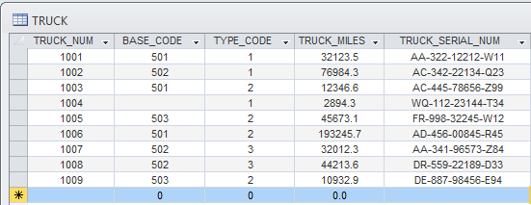

Table Name:- BASE

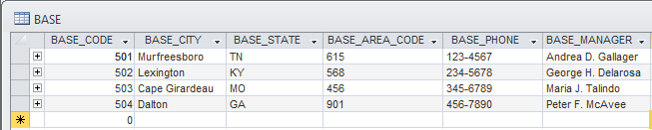

Table Name:- TYPE

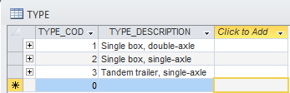

1. For each table, identify the primary key and the foreign key(s). If a table does not have a foreign key, write None.

Truck table Primary Key: TRUCK_NUM

Truck table Foreign Key: BASE_CODE, TYPE_CODE

Base table Primary Key: BASE_CODE

Type table Primary Key: TYPE_CODE

Foreign Keys for the Base and Type tables are None

1. Do the tables exhibit entity integrity? Answer yes or no and explain your answer.

Yes. Each table’s primary key (mentioned in part a) **contain** **no null** values, and **are unique**.

1. Do the tables exhibit referential integrity? Answer yes or no explain your answer.

Yes. The Truck table’s foreign keys of both Base_Code and Type_code match in values to those present in the associated entities for both Base_Code and Type_code. When a key attribute has matching values with the primary key (null permissible also but only in the foreign key’s table) then the relationship maintains data integrity of the type referential integrity.

1. Identify TRUCK tables candidate key(s).

TRUCK_NUM, and TRUCK_SERIAL_NUM

1. For each table, identify a superkey and a secondary key.

Trucks Super Key: TRUCK_SERIAL_NUM

Trucks Secondary Key: BASE_CODE, TYPE_CODE

Base Super Key: BASE_CODE, BASE_CITY, BASE_STATE

Base Secondary Key: BASE_MANAGER

Type Super Key = TYPE_CODE, TYPE_DESCRIPTION

Type Secondary Key = TYPE_DESCRIPTION??

1. Create the ERD for this database.

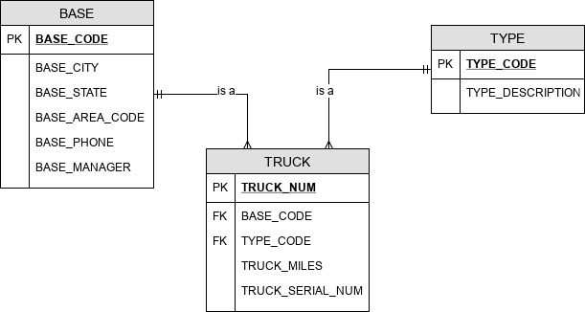

1. Create the relational diagram for this database.

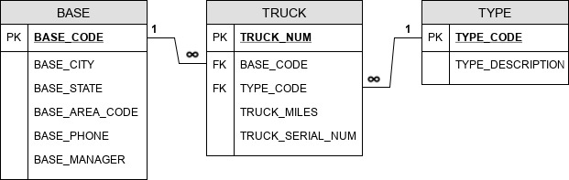

**Problem 2**:- [16 Points]

The Jonesburgh County Basketball Conference (JCBC) is an amateur basketball association. Each city in the county has one team as its representative. Each team has a maximum of 12 players and a minimum of 9 players. Each team also has up to three coaches (offensive, defensive, and physical training coaches). During the season, each team plays two games (home and visitor) against each of the other teams. Given those conditions, do the following:

1. Identify the connectivity of each relationship.

|  |  |  |  |
| --- | --- | --- | --- |
| Relationship Entities | Relationship | Connectivity | Cardinality |
| Team, City | 1:1 |  | [Team] connector: (1,1)  [City] connector: (1,1) |
| Team, Player | 1:M |  | [Team] connector: (1,1)  [Player] connector: (9,12) |
| Team, Coaches | 1:M |  | [Team] connector: (1,1)  [Coaches] connector: (1,3) |
| County, City | 1:M |  | [County] connector: (1,1)  [City] connector: (M) |

1. Identify the type of dependency that exists between CITY and TEAM.

Teams are existence-dependent on Cities, and must be associated directly with a city.

1. Identify the cardinality between teams and players and between teams and city.

Teams and players have relationship 1:M with cardinality of 9 to 12 players on a team, and for the reverse connector involved in relationship (i.e. the 1 in the 1:M) is a cardinality of 1 for the single team each player is assigned to play with.

Assuming that cities have only one team the cardinality is 1 for both sides of the relationship between team and city.

1. Identify the dependency between coach and team and between team and player.

Coaches and Players are existence-dependent on a Team. The explanation for how it is implemented is a mandatory foreign key referring to the Team table (business rules would ensure that).

1. Draw the Chen and Crow’s Foot ERDs to represent the JCBC database.

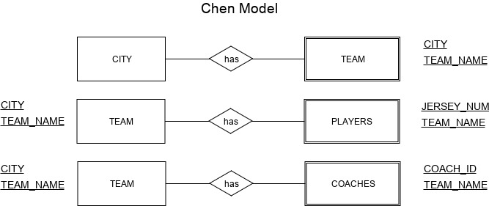**NOTE: I realize this Chen model diagram is incorrect and I will make every effort to get a similar question correctly diagrammed in future instances with another Chen diagram in the future. Same for ERD and UML.**

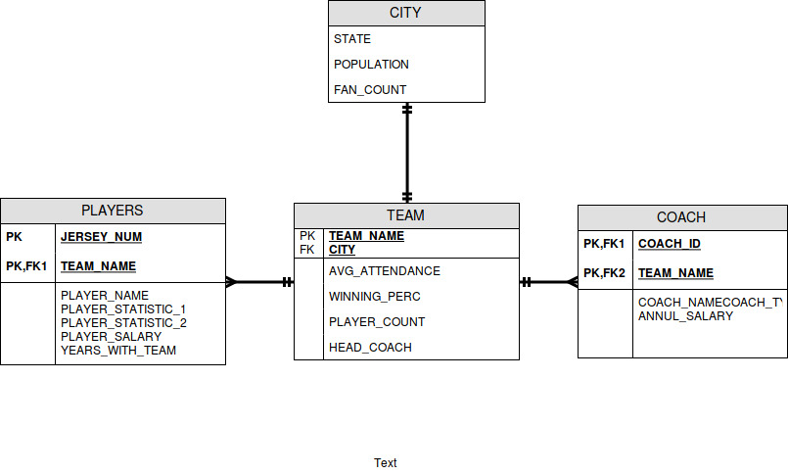

ERD Diagram

1. Draw the UML class diagram to depict the JCBC database.

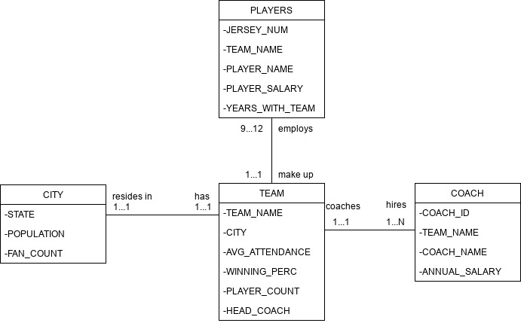

UML Diagram

**Problem 3**:- [10 Points]

Create an ERD based on the Crow’s Foot notation, using the following requirements:-

1. An INVOICE is written by a SALESREP. Each sales representative can write many invoices, but each invoice is written by a single sales representative.
2. The INVOICE is written for a single CUSTOMER. However, each customer can have many invoices
3. An INVOICE can include many detail lines (LINE), each of which describes one product bought by the customer.
4. The product information is stored in a PRODUCT entity.
5. The product’s vendor information is found in a VENDOR entity.

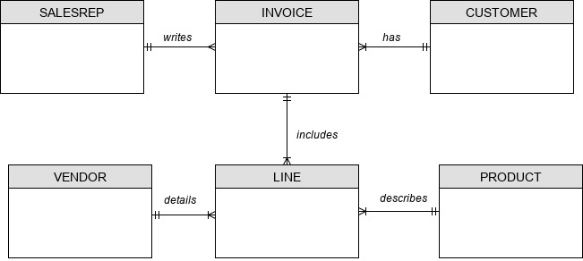

**Problem 4:- [11 Points]**

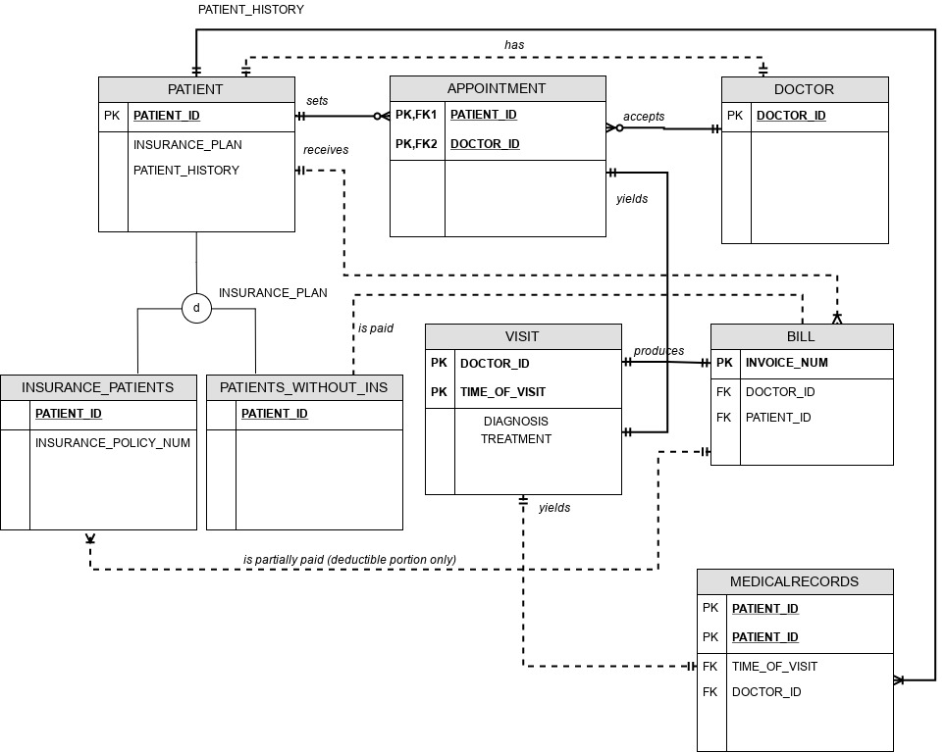Using the Crow’s Foot notation, create an ERD that can be implemented for a medical clinic, using the following business rules:

*NOTE: Please note a few of the relationship lines are probably not needed, such as the entities that are already related via other entities. One example of an unnecessary line is the relationship drawn from patient to doctor (since the line is implied because of the bridge association using appointment entity).*